**BUILDING A WEBSITE USING CANVA**

**Team ID :** NM2023TMID06405

**Team Leader Name:**

R.Devadharshini (8897B97CE4309E7A8074BFECC1126371)

**Team Members:**

S.Pooja Sri (B9A59CC5F934AE883274F1044A36A25D)

T.Reshma (39B23D84D2555D2A3024510F9649B72B)

T.Thilagasivani (EC9919E02F6A5E6AF4A4F5BC3C98AB20)

**AMORA’S CLOSET**

**INTRODUCTION**

In the realm of fashion and textiles, a textile firm is a vibrant enterprise that presents chances for growth, innovation, and creativity. Our everyday lives depend on textiles for both practical and decorative reasons, and the textile industry is vital to both production and fashion. Keeping up with fashion trends, managing supply chains, and adjusting to shifting customer tastes are all necessary for success in the textile industry. In this evergreen market, your textile business may prosper with a dedication to quality and innovation.

**PURPOSE**

The uses of textiles are diverse and encompass both industrial and personal spheres.

* **Clothes & Fashion:** Textiles are mostly used to make clothes and fashion accessories, giving us a large selection of textiles for various times of year, events, and looks. In addition to its practical uses, including comfort and protection, they also have aesthetic benefits, letting people show off their own sense of fashion and cultural identity.
* **Technical and Industrial Applications:** Textiles are used in more than just apparel and interior design.

**RESULT**

* Satisfaction: The pricing, design, and quality of the textile you receive may satisfy you if you choose a reliable online shop and carefully read product descriptions and reviews.
* Convenience: Perusing a vast array of textiles and designs from the comfort of your home is made possible by the ease of online shopping for textiles.
* Variety: When it comes to textiles, online retailers frequently provide a wider selection than brick-and-mortar stores, encompassing fabrics from various areas and designers.
* Cost Savings: While purchasing textiles online, you can frequently find affordable rates and special offers.
* Personalization: Certain internet-based merchants of textiles have customization features that enable you to select particular designs, hues, and numbers to meet your requirements.
* Accessibility: Textiles are easily accessible through online buying, even if you

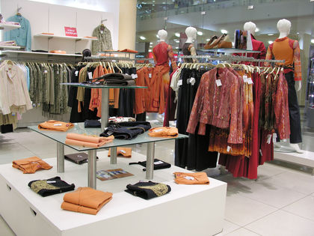

**ADVANTAGES**

* Adaptability in a range of settings.
* Breathability and comfort—perfect for bedding and clothes.
* Durability, which lowers the requirement for replace.
* A wide range of colors and patterns in terms of aesthetics.
* Advantages for the environment from sustainable solutions.
* Insulation against the cold and heat.
* Lightweight for outdoor gear and sports attire.
* Absorbance of moisture, particularly in athletic apparel
* Both affordability and cost-effectiveness.
* Simple upkeep and sanitation.
* Options for personalizing designs through customization.
* Qualities for safety, such as resistance to flames.
* Natural fibers' capacity to biodegrade.
* The advantages of antimicrobial textiles for hygiene and health.
* Safety in the fields of sports, construction, and healthcare.
* Expanding the textile industry's efforts towards sustainability.

**CHALLENGES**

* **Security concerns:** Possibilities of fraud and data theft.
* **Fit and Sizing:** Having trouble selecting the correct when buying clothes.
* **Exchanges and returns:** difficult, drawn-out procedures.
* Shipping problems include extra expenses, delays, and damage.
* **Product Quality:** It's challenging to evaluate online.
* **Issues with payments:** Disruptions pertaining to transactions.

**APPLICATION**

Customers can buy a variety of goods and services online thanks to online shopping, which offers ease of use, a large selection, and the opportunity to compare costs from different suppliers. Additionally, it is an essential platform for companies to connect with a worldwide clientele, supporting auction sites, e-commerce, and more.

**CONCLUSION**

The ease and wide range of products available while shopping online has completely changed the retail industry. However, there are drawbacks as well, like sizing problems, security concerns, and a lack of in-person support. In spite of these obstacles, it has grown to be a crucial component of contemporary trade, altering the way that we purchase and sell goods.